POWER BI SUBMISSION REPORT

Hey Team,
Myself Venkata Ramu Dandamudi and this is my Project Submission for the POWER BI Capstone Project. Given is a Nexus Goods store dataset that contains seller and customer state, city Identitites and the product categories and the product design and the order placement with placed date, shipping date and estimated delivery date and Product Reviews and Product Payments and Payment Value and Payment Type and many more. The questions and answers are answered below with the visualizations and explanations written below. If possible, please Email or let me know if any changes are required and any type of chart improvements can be done.

Q1) Identify and visually represent the top 10 product categories by sales.
- Visualization:

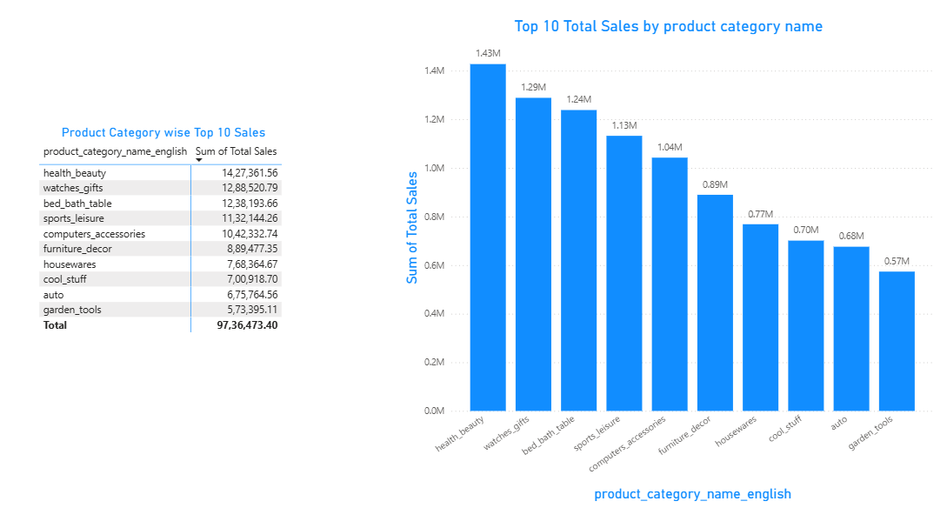
Explanation:
I analyzed the top 10 product categories by total sales to identify major revenue contributors. Health & Beauty (1.43M) leads overall sales, followed by Watches & Gifts (1.29M) and Bed Bath & Table (1.24M), indicating strong customer demand. Sports & Leisure (1.13M) and Computers & Accessories (1.04M) show stable mid-level performance. Categories such as Furniture & Decor (0.89M) and Housewares (0.77M) contribute moderately to total sales. Lower-performing categories like Auto (0.68M) and Garden Tools (0.57M) looks like potential areas for improvement or niche demand.

Q2) Delayed Order Analysis.
- Visualization:

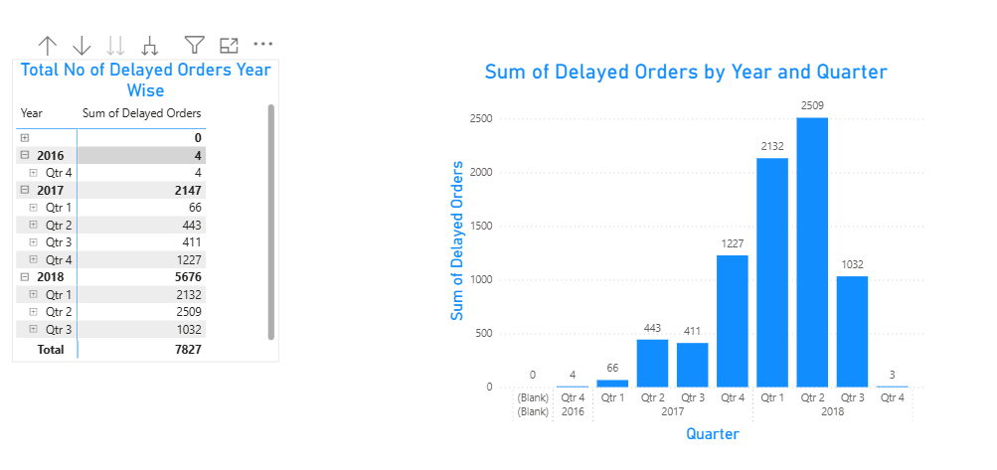

Explanation:
I analyzed the year-wise and quarter-wise distribution of delayed orders to understand delivery performance trends over time using the given condition “Actual delivery date > Estimated Delivery Date”. The data shows minimal delays in 2016 (4 orders), indicating stable operations during the early period. In 2017, delayed orders increased significantly to 2,147, with the highest delays occurring in Q4 (1,227), highlighting growing fulfillment challenges. The situation worsened in 2018, where delayed orders peaked at 5,676, driven mainly by Q1 (2,132) and Q2 (2,509), indicating sustained operational pressure. Overall, the analysis reveals a sharp upward trend in delayed orders over time,( might be due to increase in volume of orders in the delivery time or longer order processing times) emphasizing the need for improved logistics and delivery planning during high-volume periods.

Q3) Monthly Comparison of Delayed and On-Time Orders.
- Visualization:

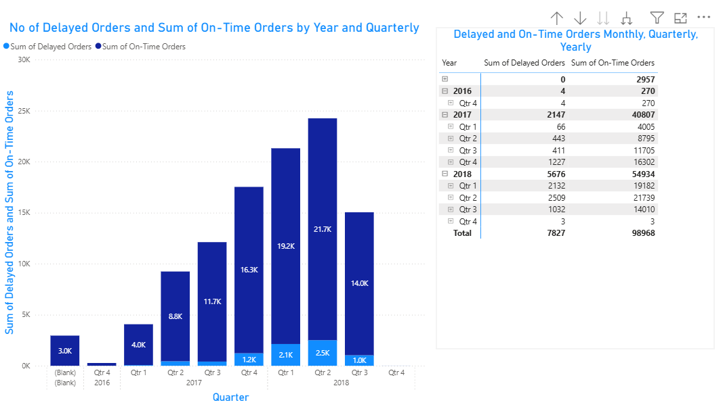

Explanation:
I analyzed the yearly and quarterly comparison of delayed versus on-time orders to evaluate overall delivery performance trends. While on-time deliveries consistently outnumber delayed orders, the gap narrows significantly during periods of high order volume. In 2017, delayed orders rose to 2,147, with on-time deliveries reaching 40.8K, indicating increasing operational pressure. The situation intensified in 2018, where delayed orders peaked at 5,676, particularly in Q1 (2.1K) and Q2 (2.5K), despite strong on-time performance of over 54.9K orders. Overall, the visual highlights that although the majority of orders are delivered on time, delivery delays increase proportionally during peak demand periods, signaling the need for improved logistics scalability.

Q4) Payment Method Analysis.

- Visualization:

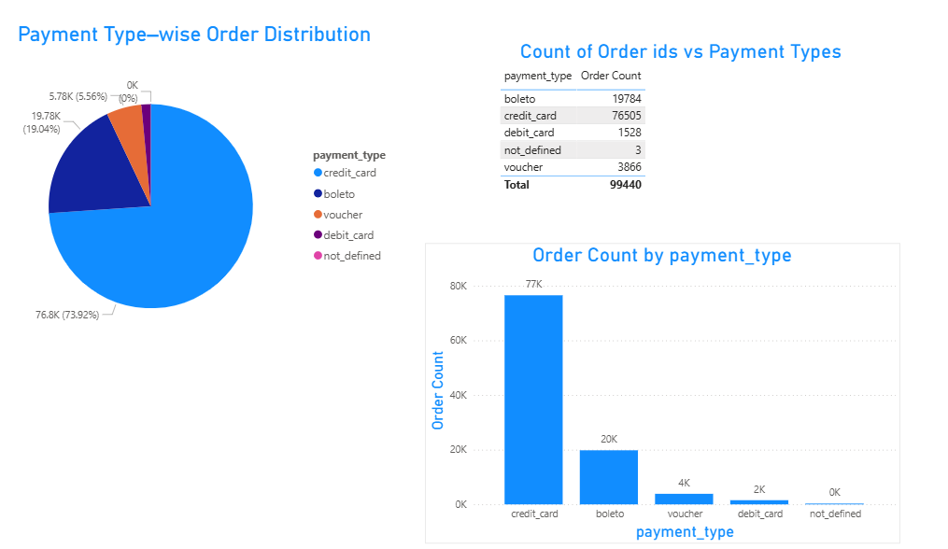

Explanation:
I analyzed the distribution of orders by payment type to understand customer payment preferences. Credit cards dominate the platform, accounting for ~76.8K orders (≈74%), indicating a strong preference for digital and instant payment methods. Boleto is the second most used option with ~19.8K orders (≈19%), showing continued adoption of alternative offline payments. Vouchers (~3.9K) and debit cards (~1.5K) contribute only a small share, suggesting limited customer reliance on these methods. The “not_defined” category (~3 orders) is assumed to represent cases where payment-type data was not captured or provided, and its negligible volume does not impact overall insights. Overall, the results highlight a clear dependency on credit-card payments, which is critical for payment gateway and fraud-management strategies.

Note:

Total Sales = Product Price + Freight Value

Q6) State-wise Total Sales Analysis.
- Visualization:

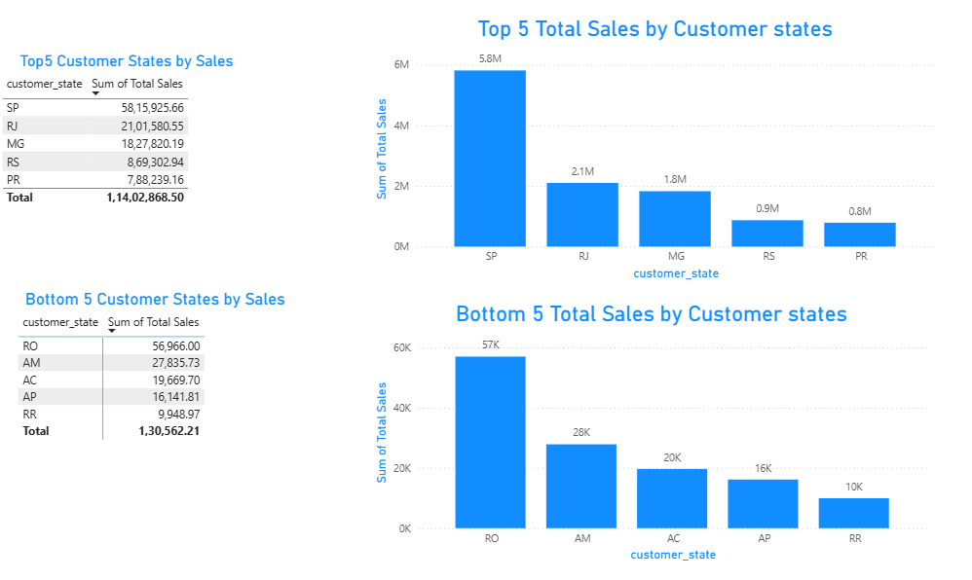

Explanation:
I observe that São Paulo (SP) clearly dominates total sales with approximately 5.8 M, making it the strongest revenue-contributing state by a wide margin. This is followed by Rio de Janeiro (RJ) at around 2.1 M and Minas Gerais (MG) at 1.8 M, which together form a strong second tier but still fall significantly behind SP. Rio Grande do Sul (RS) (0.9 M) and Paraná (PR) (0.8 M) complete the top five, indicating moderate but consistent sales performance. On the lower end, Rondônia (RO) leads the bottom group with roughly 57 K, followed by Amazonas (AM) (28 K) and Acre (AC) (20 K). Amapá (AP) (16 K) and Roraima (RR) (10 K) record the lowest sales, highlighting a clear regional imbalance where revenue is heavily concentrated in a few major states.

Note:

Total Sales = Product Price + Freight Value

Q7) Seasonal sales pattern (Quarterly/Yearly).
- Visualization:

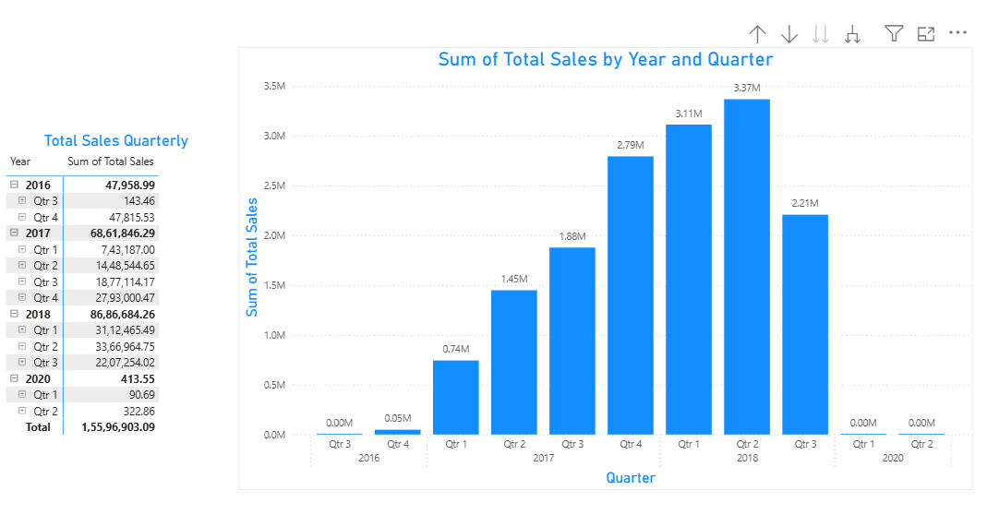

Explanation:

I observe that total sales show a clear upward trend over time, with very minimal activity in 2016, where sales remain almost negligible at around 0.05 M by Q4. A strong growth phase begins in 2017, starting at approximately 0.74 M in Q1 and steadily increasing each quarter, reaching about 2.79 M by Q4, which indicates rapid expansion and improving market traction. This momentum continues into 2018, where sales peak at around 3.37 M in Q2, marking the highest quarterly performance across the entire timeline. However, after this peak, sales decline to roughly 2.21 M in Q3 of 2018, suggesting a slowdown or possible market saturation. Post-2018, sales drop sharply, with 2020 quarters showing almost 0.00 M, which may indicate incomplete data or a significant disruption impacting business operations during that period.

Q8) Revenue Analysis.
- Visualization:

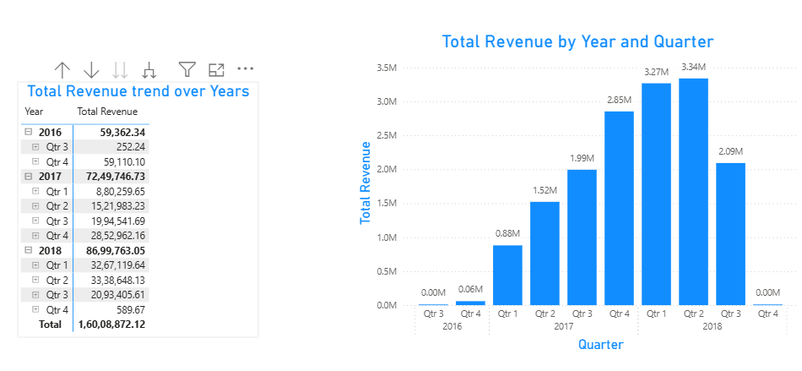

Explanation:

I observe that total revenue follows a growth pattern similar to sales, starting at a very low level in 2016, where revenue remains almost negligible at around 0.06 M by Q4. A strong upward trend begins in 2017, with revenue rising from approximately 0.88 M in Q1 and consistently increasing each quarter, reaching about 2.85 M by Q4, which reflects strong business expansion and improved monetization. This positive momentum continues into 2018, where revenue peaks at around 3.34 M in Q2, marking the highest quarterly revenue across the entire period. After this peak, revenue declines to roughly 2.09 M in Q3 of 2018, indicating a slowdown in performance or external business constraints. The sharp drop to nearly 0.00 M in Q4 2018 suggests either missing data or an operational disruption, rather than a natural revenue trend.

Note:

Here, Revenue = Sum(Payment Value) in the Payment Dataset

-------------THANK YOU-----------------

